North American Sports
basketball | football | soccer | baseball
volleyball | hockey | track and field | boxing
Instructions: Read the paragraph and guess the sport. Write the name of the sport on the line.
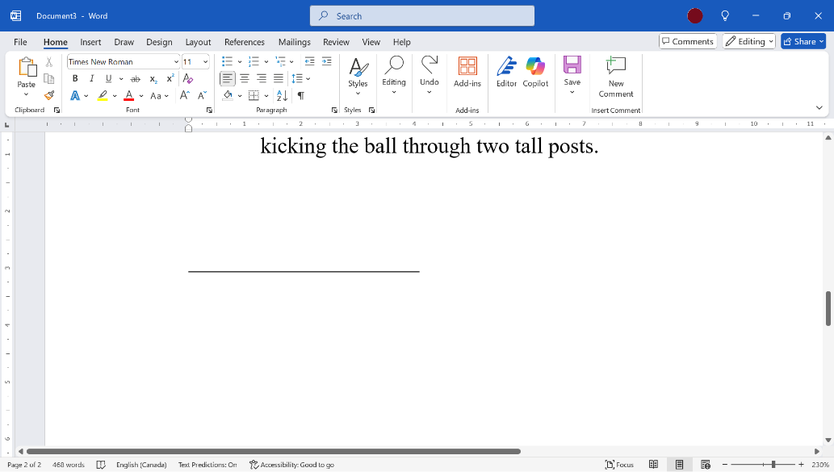
- This sport is played with a piece of wood called a bat and a small white ball. Two teams take turns. One team hits the ball, and the other team tries to catch it. The player with the bat tries to hit the ball and run to four spots on the field. If they touch all the spots they score a point. The other team tries to stop the runner by catching the ball or touching the runner with the ball. The team with the most points wins.
- This sport is played with a round ball. Two teams try to kick the ball into a net. Players cannot touch the ball with their hands, only their feet, head, or body. The goalkeeper is the only player who can use hands. The team with the most goals wins.

- This sport is played with a round ball and a high net. Two teams hit the ball over the net with their hands. Players cannot catch the ball. The goal is to make the ball touch the ground on the other side. The first team to reach a certain number of points wins.

- This sport is played with an orange ball. Two teams try to throw the ball into a high net. Players run, pass, and bounce the ball while moving. Each team gets points when the ball goes into the net. The team with the most points at the end wins.

- This sport is a fight between two people. They wear gloves and try to hit each other. The fight happens in a square ring. The winner is the person who gets the most points or makes the other person stop fighting.

- This sport includes running, jumping, and throwing. Some athletes race to see who is the fastest. Others try to jump the highest or longest. Some throw heavy objects to see who can throw the farthest. The athlete with the best time or distance wins.

- This sport is played on ice with skates. Players use a stick to hit a small black disc. Two teams try to shoot the disc into the other team’s net. The team with the most goals wins. Players wear helmets and pads to stay safe.

- This sport is played with an oval-shaped ball. Two teams try to carry or throw the ball to the end of the field. The other team tries to stop them by tackling or blocking. Teams score points by crossing the line at the end or kicking the ball through two tall posts.

Sports Discussion
- What is your favourite sport? Why?
- Do you like to watch your favourite sport on TV?
- Do you like to play your favourite sport?
- Did you do track and field at school?
- Do you know the rules of baseball?
- Do you like football or soccer more?

Sports Sentence Challenge
Instructions: Find a classmate and decide who will be Player 1 and who will be Player 2. Player 1 writes the first word of a sentence in Round 1. Player two write the second word of the sentence. Player 1 writes the third word, etc. There are 2 ways to score a goal:
- If your classmate makes a spelling, grammar or vocabulary mistake, you score a goal.
- If your classmate cannot think of a word to continue the sentence in 15 seconds, you score a goal.
When neither player can continue the sentence, go to the next Round.
Round 1: _____________________________________________________________________________________________________________________________________________________________________________________________
Round 2: _____________________________________________________________________________________________________________________________________________________________________________________________

Round 3: _____________________________________________________________________________________________________________________________________________________________________________________________
Player 1 Goals ___________ Player 2 Goals: ___________

